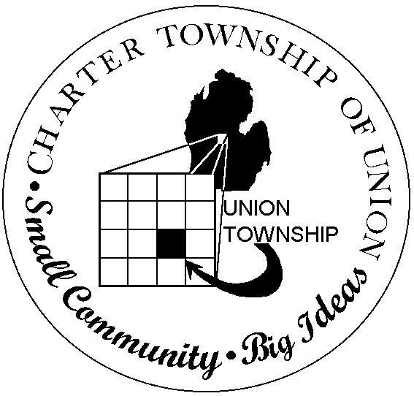
.00
CHARTER TOWNSHIP OF UNION
BOARD OF TRUSTEES
REGULAR MEETING
April 25, 2012
7:00 p.m.

- CALL MEETING TO ORDER

- PLEDGE OF ALLEGIANCE

- ROLL CALL

- PUBLIC COMMENT: Restricted to three minutes regarding issues on this agenda

- REPORTS/BOARD COMMENTS

- APPROVAL OF AGENDA

- CONSENT AGENDA
- Communication
- Isabella County Recycling Program 2012 Monthly Participation Rate
- Minutes – April 11, 2012 Regular Meeting
- Bills
- Payroll
- 2.5 Financial Conditions and Activities
- 2.5.10 Cash Flow Ratio
- 2.6 Asset Protection
- 3.4 Agenda Planning
- Budget Amendments

- BOARD AGENDA
- Land Division – Claudia Joslin, parcel #14-018-20-002-02
- Land Division – Bruce Ball, parcel #14-029-40-002-06
- Joint Resolution on Personal Property Tax Proposals
- Resolution to Eliminate the Refunds and Overpayments on Taxes under $5.00

- EXTENDED PUBLIC COMMENT

- FINAL BOARD MEMBER COMMENT

- ADJOURNMENT

